Introduction to NoSql final assignment
Task 1: Import movies.json into mongodb server into a database named entertainment and a collection named movies

mongoimport --host 172.21.194.246 -u root -p YDOWABlZKMtk9V8nHsiFFG18 --authenticationDatabase admin --db entertainment --collection movies --file movies.json –jsonArray

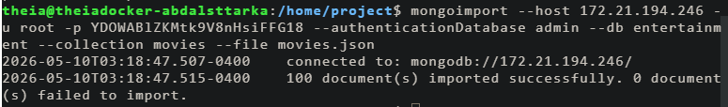

Task 2: Write a mongodb query to find the year in which most number of movies were released
db.movies.aggregate([
{
"$group":{
"_id":"$year",
"moviecount":{"$sum":1}
}
},
{
"$sort":{"moviecount":-1}
},
{
"$limit":1
}
])

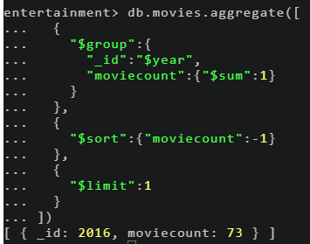
Task 3: Write a mongodb query to find the count of movies released after the year 1999
db.movies.aggregate([
{
$match: { year: { $gt: 1999 } }
},
{
"$group":{
"_id": null,
"moviecount":{"$sum":1}
}
},
{
"$sort":{"moviecount":-1}
}
])
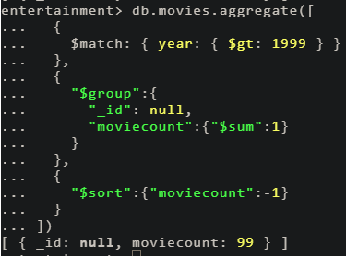

Task 4: Write a query to find out the average votes for movies released in 2007
db.movies.aggregate([
{
$match: { year: 2007 }
},
{
"$group":{
"_id":null,
"averagevote":{"$avg":"$Votes"}
}
}
])
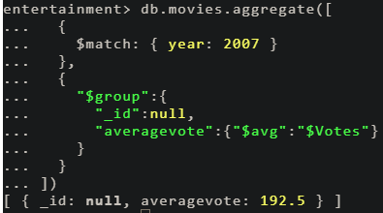

Task 5: Export the fields _id, title, year, rating and Director from the movies collection into a file named partial_data.csv
mongoexport --host 172.21.194.246 -u root -p YDOWABlZKMtk9V8nHsiFFG18 --authenticationDatabase admin --db entertainment --collection movies --out partial_data.csv --type=csv --fields _id,title,year,rating,Director
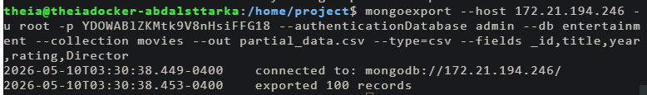

Cassandra part

Task 6 - Create a keyspace named entertainment

CREATE KEYSPACE entertainment
WITH replication = {
'class': 'SimpleStrategy',
'replication_factor': 3
};
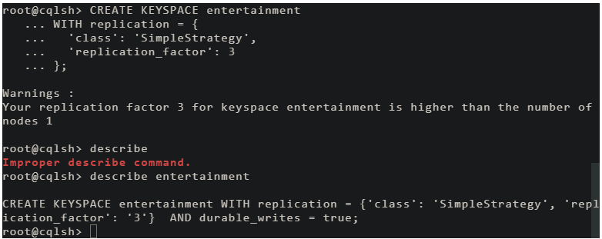

Task 7 - Import partial_data.csv into cassandra server into a keyspace named entertainment and a table named movies
CREATE TABLE movies(
id text PRIMARY KEY,
title text,
year text,
rating text,
director text
);

COPY entertainment.movies(id,title,year,rating,director)
FROM 'partial_data.csv'
WITH DELIMITER=',' AND HEADER=TRUE;

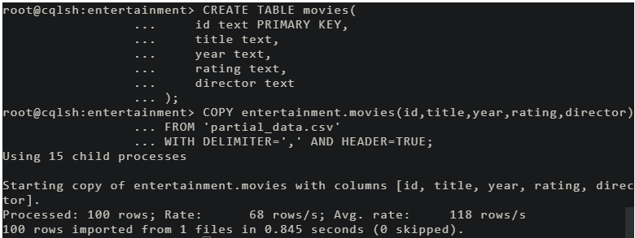

Task 8 - Write a cql query to count the number of rows in the movies table
Select count(*) from movies;
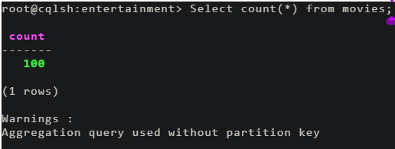

Task 9 - Create an index for the rating column in the movies table using cql
Create index if not exists index_rating on entertainment.movies (rating);
Describe movies;
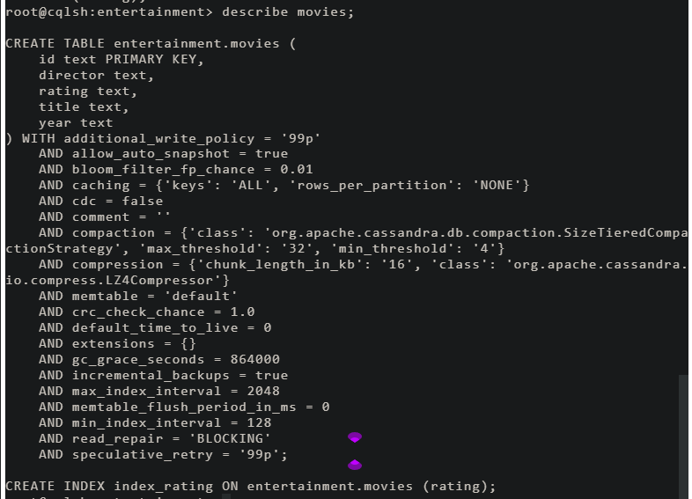
Task 10 - Write a cql query to count the number of movies that are rated 'G'.
select count(*) from movies where rating='G';
